***Tutorial***

**PLEASE READ CAREFULLY**

1. **Task Overview**

In this task, you will learn to differentiate 4 facilities using simulated geospatial (map-like) data. The task will take 2-3 hours, and breaks will be provided. Taking notes or using external devices is not permitted.

1. **Data**

There are 3 categories of data associated with the task. Each category is presented in a “layer,” and different layers can be presented simultaneously.

* 1. IMINT (Image Intelligence): the location and shape of a building, water features, and the presence or absence of rooftop hardware, e.g., a satellite dish.

|  |  |
| --- | --- |
| IMINT.jpg |  |

* 1. SIGINT (Signals Intelligence): intelligence gathered by the interception of signals; each ‘hit’ denotes an intercepted signal at that location (e.g., a government-issued cell phone).

|  |  |
| --- | --- |
| SIGINT.jpg |  |

* 1. MASINT (Measurement and Signature Intelligence): chemical intelligence; each ‘hit’ denotes that a chemical has been detected at that location.

|  |  |
| --- | --- |
| MASINT.jpg |  |

1. **Facilities**

Over the course of the task, you will learn to identify 4 fictitious facilities (e.g., ketchup-, mustard-, salt- and pepper-producing factories). Facilities will differ in appearance from one another (for instance, SIGINT may be reliably associated with one facility but not another; see example below). It is your job to identify and leverage these differences to classify a number of unknown facilities.

|  |  |
| --- | --- |
| **Ketchup Factory** | **Mustard Factory** |
|  |  |

***What do I need to know to identify a facility?***

IMINT

* The presence or absence of water.
* The presence or absence of rooftop hardware.
* The number of buildings present.
  + The shape of those buildings.
  + The spatial configuration of those buildings.

SIGINT

* The number of ‘hits.’

MASINT

* The chemical identified.
* The number of ‘hits’.

***What don’t I need to know to identify a facility?***

* The orientation of a building.
* The orientation of buildings with respect to one another.
* The orientation of the facility itself.

1. **Scenes**

Each scene is comprised of 2-4 sectors, denoted by a dotted black line. Each sector contains a single facility.

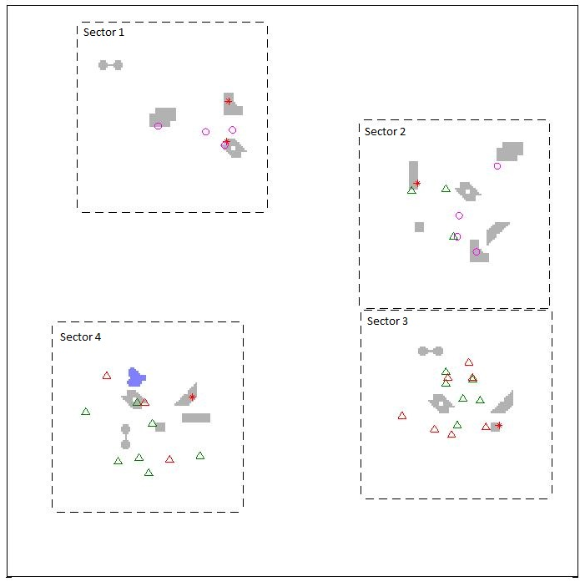

1. Questions

The test will comprise of a series of multiple-choice questions. You will be asked to either:

1. ***Locate*** a candidate facility in the scene, or
2. ***Identify*** a facility in a particular sector.

The data will be presented ‘simultaneously’ (all at once), ‘sequentially’ (one layer at a time), or ‘sequentially based on user choice’ (you will be asked which layer you would like to see next).

***All responses will be in the form of likelihoods (e.g., the probability that a particular sector contains a facility).***

|  |  |
| --- | --- |
|  | (Left) A screenshot of the GUI you’ll use to report probabilities; you’ll have a chance to practice with the actual GUI before starting the task. |
|  | For each probability assessment, answers can be reported in one of two ways:   * Drag the bar up or down (red circle, solid) * Click the up/down arrow (red circle, dotted).   The shaded region shows your previous probability assessment (defaults to 25%). The number at the bottom is the sum of all 4 probability assessments (green circle) |
|  | The GUI will automatically normalize your answers (so they sum to 100%) before proceeding to the next question.  Final answer (left): 53% likely the target facility is a Ketchup Factory, 8% likely the target facility is as Mustard Factory etc. |

1. Training

You will have the opportunity to train to improve your facility-identification performance throughout the task. Training can take one of two forms:

* 1. Annotation: Scenes will be presented one at a time; in each, one or more facilities will be labeled (see below).

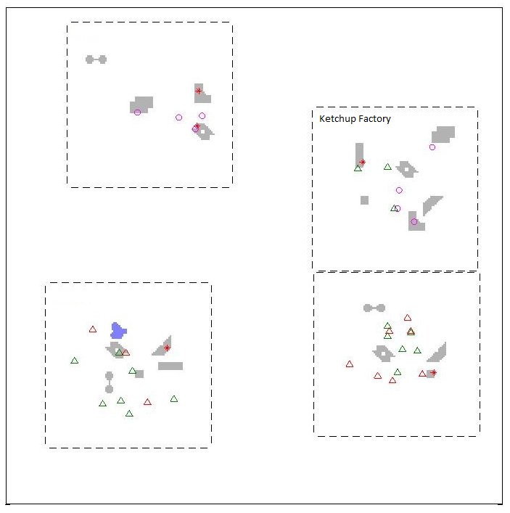

* 1. Rules: You may be presented with a ‘rule’ to help you distinguish one facility from another. Rules can be revisited at any time during the task.

*Examples:*

* Ketchup Factories contain more than 1 piece of rooftop hardware.
* Salt Factories are located in the same sector as water 80% of the time.

**If you have any questions, please ask now. If not, please continue.**